Fontys University of Applied Sciences

Eindhoven, The Netherlands

User Requirement

PROCP

AIRPORT LUGGAGE SIMULATION

Team IT Rockstars | 11-September -2020

**Group E**

**Team members:**

Aleksander Sopiqoti

Bilal Delal Aktas

Fadi Abboud

Emad Albouni

Obaid Ghafoori

Ralia Larmonie **Tutor:** Mr. Emin Thaqi

Table of Contents

**Version History** **3**

**User Requirement** **4**

Functional requirement **4**

User 4

System 4

**Non-functional requirement** **5**

**Use Cases** **6**

Login 6

Create an account 7

Create a new simulation 7

Log in 8

Start simulation 9

Stop simulation 10

Save simulation 10

Reset Simulation 11

Import 12

Export 13

Drop & Drag model building 14

Restart simulation 14

Show Statistics 15

Start Animation 15

**GUI Design** **17**

## Version History

|  |  |  |  |
| --- | --- | --- | --- |
| **Version** | **Created on:** | **Reviewed by:** | **Remark** |
| 1.0 | 12.09.2020 |  |  |
| 2.0 | 21.09.2020 |  |  |
| 3.0 | 06.01.2021 |  |  |

## User Requirement

## Functional requirement

### User

|  |  |
| --- | --- |
| Features | MoSCoW |
| Start a simulation | Must |
| Stop a simulation | Must |
| Save simulation results | Must |
| Input the necessary information for the (check-in desk, timetable of flights, number of passengers) | Should |
| Export and import and a file | Should |
| Fast-forward a simulation | Should |
| Login (authorization) | Could |
| Select and unselect conveyor belt. | Could |
| Restart a simulation | Could |

### System

|  |  |
| --- | --- |
| Features | MoSCoW |
| Determine the optimal way of handling luggages   1. Transport the luggages. | Must |
| Shows a visual representation | Should |
| “Drag & Drop” model building  Graphical user interface. | Would |
| A guide video for operating the application | Would |
| Starting with a pre-designed basic model airport luggage simulation | Would |
| Show statistics | Would |
| Shows Animation | Must |

## 

## Non-functional requirement

* Windows forms app (.NET framework) will be used for the graphical user interface
* Software will be programmed in C#
* Before the release of the simulation software, the software would be tested and deliver it successfully .
* The application would present user-friendly design.
* Simulation software will be stable throughout the simulation.

## 

## Use Cases

### Login

|  |  |
| --- | --- |
| Use case | Login |
| Actor | User |
| Pre Condition(s). | * User is already created an account in the system. |
| Main Success Scenario | This use case starts when the User accesses the sign-in feature of the system.   1. The system prompts the User for his/her username and password. 2. The User enters his/her username and password. 3. The system validates the entered information, making sure that the entered username and password are valid for one user account in the system, and that the required password is entered for the entered username. 4. The User is signed in. The system displays a message indicating that the user is signed in. 5. The use case ends. |

### 

### Create an account

|  |  |
| --- | --- |
| Use case | Create an account |
| Actor | Airport Officer |
| Description | The Create Account use case allows the user to create a login and become a Registered User. |
| Pre Condition(s). | None |
| Main Success Scenario | This use case starts when the User accesses the system feature that enables him/her to create an account by entering information that is maintained in the User’s account.   1. The User enters the required User Account information values and requests that the system saves the entered values. 2. The system validates the entered User Account information. 3. The values for the User Account information are stored in the User’s account. The system notifies the user that the account has been created. 4. The use case ends |

### Create a new simulation

|  |  |
| --- | --- |
| Use case | Create a new simulation |
| Actor | User |
| Pre Condition(s). | * Simulation application has been started * User has been logged in |
| Main Success Scenario | 1. Start Plant Simulation.  2. Choose to Create a New Model.  3. Click 3D only in the dialog window that pops up. |

### 

### 

### Log in

|  |  |
| --- | --- |
| Use case | Log in |
| Goal | Accessing to the Applications |
| Actor | Airport Officer |
| Pre Conditions | The Actor is already registered in the system |
| Main success Scenario | 1. Actor inputs his/her credentials. 2. Actor presses on the login button. 3. System verifies the account. 4. Actor is logged in. |
| Extensions | **3a. Required to be input fields are empty.**   1. System shows an appropriate message. 2. System asks the Actor to fill the details. 3. Actor changes the details for authorization. 4. Go back to MSS step 2.   **3b. System cannot verify the account.**   1. System shows an appropriate message. 2. Go back to MSS step 1. |

### 

### Start simulation

|  |  |
| --- | --- |
| Use case | Start simulation |
| Goal | To start the simulation application successfully |
| Actor | Airport Officer |
| Pre Condition(s). | User has been logged in and verifies his/her credentials |
| Trigger | User signals to the system that a simulation will be starting |
| Main Success Scenario | 1. Airport Officer inputs number of flights, carts and employees. 2. Airport Officer clicks on the choose Baggage Flow. 3. The system validates input data. 4. The Actor creates the path for baggage flow. 5. The Actor clicks on the Start Simulation button. 6. The system validates whether the path can reach from check-in to the aircraft baggage compartment. 7. The system starts the simulation. |
| Extensions | 3a. Input data is not correct.   1. The system shows appropriate message. 2. The actor changes the values for flights, carts, employees and baggage flow. 3. Use case goes to step 2 of MSS.   5a. The constructed path is not complete.   1. The system shows appropriate message. 2. Use case goes to step 4 of MSS. |

### 

### 

### 

### 

### Stop simulation

|  |  |
| --- | --- |
| Use case | Stop simulation |
| Goal | Stop the simulation process |
| Actor | Airport Officer |
| Pre Conditions | The application is running and the Simulation is started. |
| Trigger | The actor signals the 'STOP' button |
| Main success Scenario | 1. System asks for confirmation. 2. Actor presses ‘OK’. 3. System stops the simulation. |
| Extensions | 1a. Actor press cancel instead.   1. Simulation continues.   2a. Airport (Officer decides to cancel by clicking button “CANCEL”.   1. Simulation continues. |

### 

### Save simulation

|  |  |
| --- | --- |
| Use case | Save simulation |
| Goal | Actor saves the simulation result into a file |
| Actor | Airport Officer |
| Pre Conditions | The simulation has successfully finished |
| Trigger | Actor signals “save” button |
| Main success Scenario | 1. System opens file explorer on the machine. 2. Actor selects location, specifies name (a text file will be created automatically). 3. Actor presses “OK”. 4. The simulation results are saved. 5. System shows a message to describe the successful operation. |
| Extensions | **3a. Actor signals "CANCEL" instead of "OK"**   1. System shows the previous screen (finished Simulation) |

### Reset Simulation

|  |  |
| --- | --- |
| Post-Conditions | Reset simulation |
| Description | Reset. Remove all setting and reset the simulation  clock to zero. |
| Pre Condition(s). | None |
| Main Success Scenario | 1. Click on the Reset button to return the model into a predefined starting position. 2. The simulation clock should reset to zero and all setting are removed from the model |

### 

### 

### Import

|  |  |
| --- | --- |
| Use case | Import |
| Actor | User |
| Pre Condition(s). | * User has been logged in and verifies his/her credentials * User has already exported a simulation model |
| Trigger | User signals to the system that a simulation will be starting |
| Main Success Scenario | 1. System displays current simulation model or empty window 2. User selects “Import” button 3. System displays a window , promoting a user to select a proper file 4. User select and loads a file, which contains past or exported model 5. System automatically process the file and builds the model |
| Extensions | 2a,4a Actor cancels   1. Use case ends   4a Unsupported file format   1. Application shows appropriate message 2. Application goes back to step 2 of MSS   4b Corrupted file   1. Application shows appropriate message 2. Application goes back to step 2 of MSS |

### 

### 

### 

### 

### 

### 

### Export

|  |  |
| --- | --- |
| Use case | Export |
| Actor | User |
| Pre Condition(s) | User has been logged in and verifies his/her credentials |
| Trigger | User signals to the system that a simulation will be starting |
| Main Success Scenario | 1. System displays current simulation model or empty window 2. User selects “Export” button 3. System displays a window , promoting a user to save a model 4. User entitles the model 5. User save the model 6. System exports the model to selected location and return back to simulation screen |
| Extensions | 2a,4a,5a Actor cancels   1. Use case ends   5a File already exists   1. Application shows appropriate message informing the user and asks if the user want to overwrite it 2. User select to overwrite it 3. Application goes back to step 4 of MSS |

### 

### 

### 

### Drop & Drag model building

|  |  |
| --- | --- |
| Use case | Drop & Drag model building |
| Actor | User |
| Pre Condition(s). | * Simulation application has been started * User has been logged in |
| Main Success Scenario | System displays current simulation model or empty window  System displays elements on the side  User selects the element  User drags & drops element to empty terrain |
| Extensions | 3a,4a Actor cancels  Use case ends |

## 

### Restart simulation

|  |  |
| --- | --- |
| Use case | Restart simulation |
| Actor | User |
| Pre Condition(s). | * User has been logged in and verifies his/her credentials * User has already been started a simulation |
| Trigger | User signals to the system that a simulation will be starting |
| Main Success Scenario | 1. User restarts the simulation by clicking on the “Restart” button. 2. System runs the application 3. System loads the simulation successfully |
| Extensions | 1a Actor cancels   1. Use case ends   3a System load the simulation unsuccessfully   1. Application shows appropriate message 2. Application goes back to step 2 of MSS |

### Show Statistics

|  |  |
| --- | --- |
| Use case | Drop & Drag model building |
| Actor | User |
| Pre Condition(s). | * Simulation application has been started * User has been logged in * The user has already puts necessary inputs |
| Main Success Scenario | 1. System displays input data form 2. User inputs the necessary fields 3. User clicks the “Next” button 4. System shows the statistics form. |
| Extensions | 2a,3a Actor cancels   1. Use case ends |

## 

### 

### Start Animation

|  |  |
| --- | --- |
| Use case | Drop & Drag model building |
| Actor | User |
| Pre Condition(s). | * Simulation application has been started * User has been logged in * The shortest path has already determined |
| Main Success Scenario | 1. System displays current simulation model or empty window 2. User clicks the “Start Animation” button 3. System runs the application 4. System runs the animation successfully. |
| Extensions | 2a Actor cancels   1. Use case ends |

## 

## 

## 

## 

## 

## 

## 

## 

## 

## 

## 

## 

## 

## 

## 

## 

## 

## 

## GUI Design

The design will be made using the Windows Forms App (.NET framework).

Admin Panel

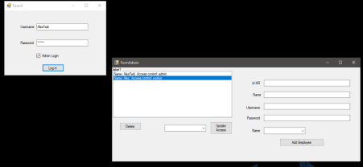

Simulation Details

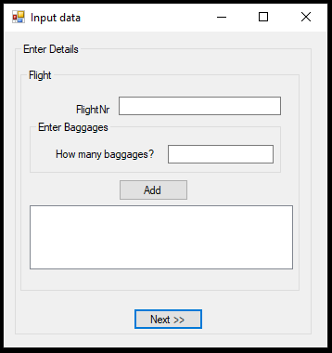

Simulation Window

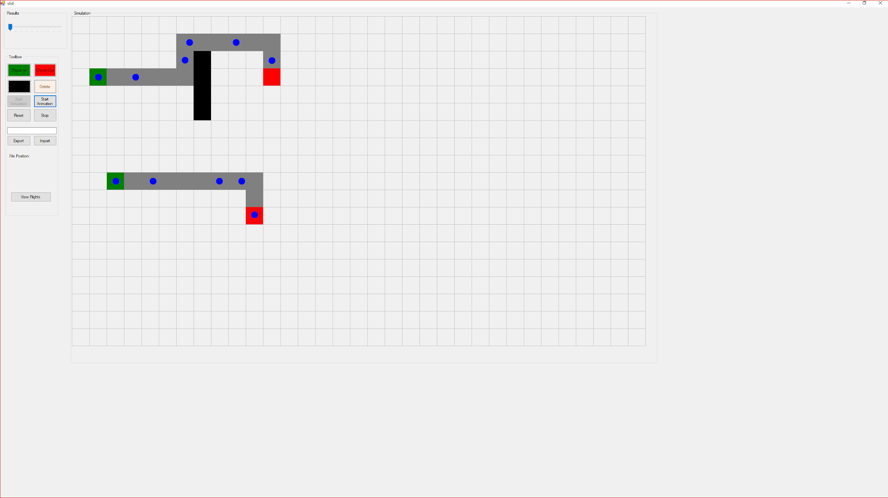

Statistics Window

